**17- 07-24 Linux**

**ls-**show files in current position

**cd-**change directory

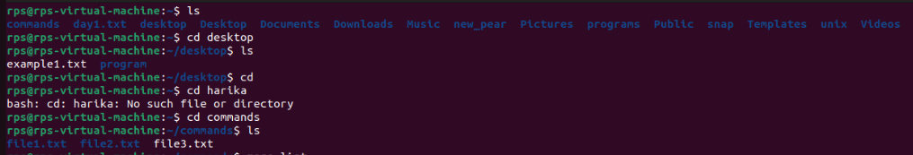

cp-copy file or directory

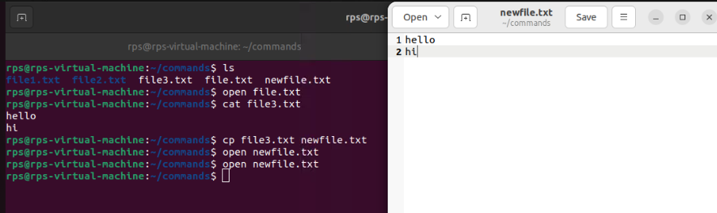

**mv-**move file or directory

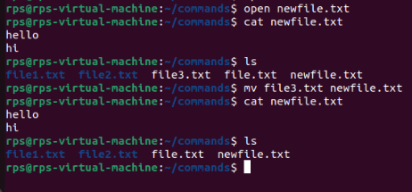

**rm**-remove file or directory

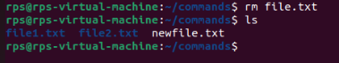

Pwd-show current postion

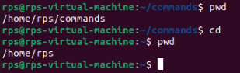

mkdir-create directory

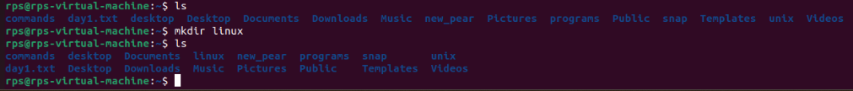

**rmdir-**remove directory

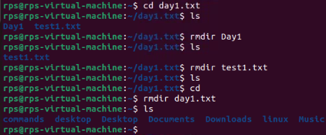

**less,more,cat-** display file contents

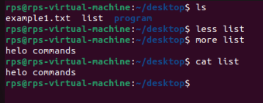

**ls-a-** list all files and directories, including hidden ones, in a directory

**ls-la-**list all files and directories, including hidden ones, in a long format with detailed information.

**ls-fa**- list all files and directories, including hidden ones, without following symbolic links.

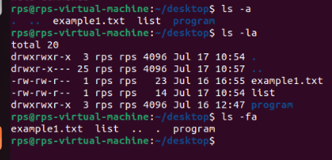

Make a directory

mkdir linux

pwd

cd linux

pwd

cd

pwd

rmdir linux

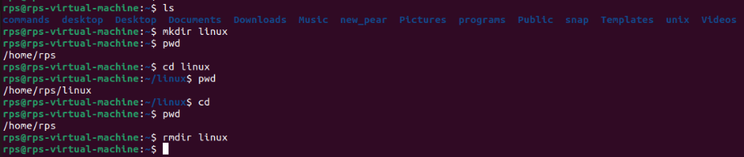

Man – man

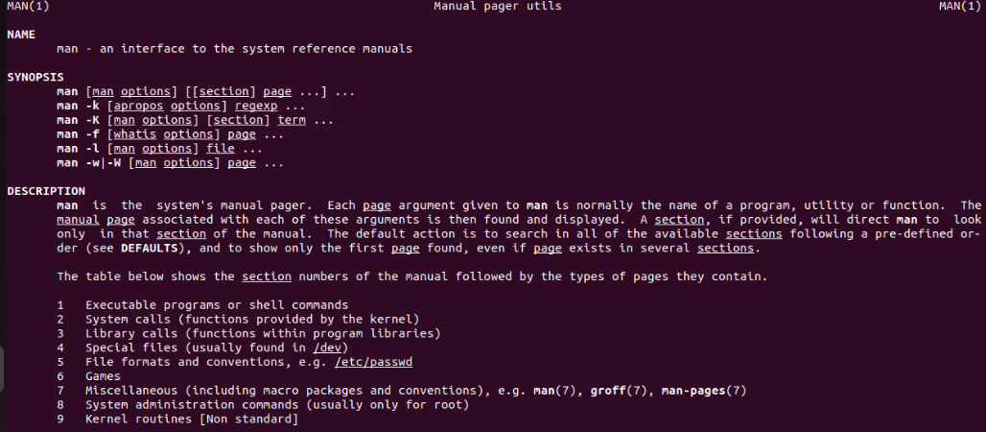

**Navigation:**

**cd (change directory): Moves you between directories.**

1. Exercise: Navigate to your home directory (cd ~), then explore subdirectories like Documents (cd Documents). Use pwd (print working directory) to confirm your location. Try going back a directory with cd ...

pwd (print working directory): Shows your current directory path.

Exercise: After navigating using cd, use pwd to verify the path.

A: Commands we used to establish the directories paths

**cd ~**

**cd Documents**

**pwd – present working directory**

**cd ..**

**pwd**

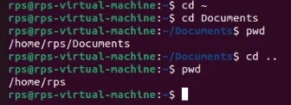

**ls (list): Lists files and directories in the current directory.**

2. Exercise: Use ls in your home directory and note the listed items. Try ls -l (long format) for detailed information like permissions, owner, and size.

A: Lists files and directories in the current directory.

**ls -** list

**ls –l -** Long format listing

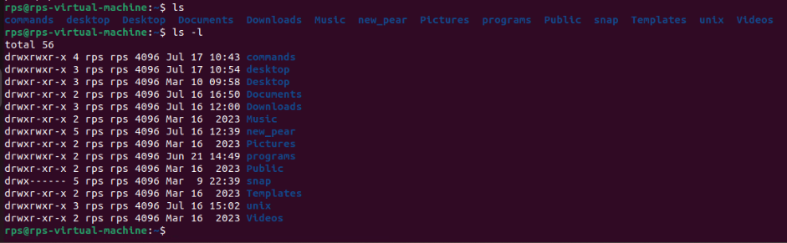

**File and Directory Management:**

mkdir (make directory): Creates a new directory.

3. Exercise: Create a new directory called "Projects" (mkdir Projects). Use ls to confirm its existence.

A: **mkdir Projects -** Create a new directory projects

**ls -** list the directories

rmdir (remove directory): Deletes an empty directory.

**rmdir – Remove the directory.**

Exercise: Make a directory named "temp" (mkdir temp). Delete it after verifying its existence with ls (rmdir temp).

**A: mkdir temp –** create a directory

**ls –** list of directories

**rmdir temp –** remove a directories

**ls –** list

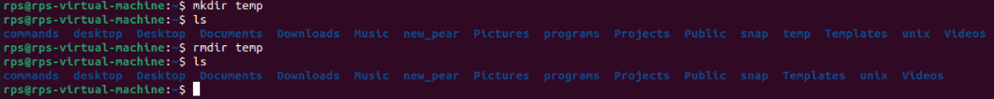

**touch (create file): Creates an empty file.**

4. Exercise: Create a file called "test.txt" (touch test.txt). Use ls to see it listed.

A: **touch test.txt -** Creates an empty file.

**Ls**

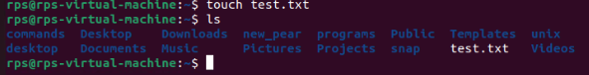

**cp (copy): Copies a file or directory to another location.**

5. Exercise: Copy "test.txt" to your Documents directory (cp test.txt Documents). Verify the copy with ls Documents.

A**: cp test.txt Documents -** Copies a file or directory to another location.

**ls Documents**



**mv (move/rename): Moves or renames a file or directory.**

6. Exercise: Rename "test.txt" to "data.txt" (mv test.txt data.txt). Use ls to confirm the change. You can also move files to a different directory (e.g., mv data.txt Documents).

A: **mv test.txt data.txt -** Moves or renames a file or directory.

**ls**

**mv data.txt Documents**

**ls Documents**

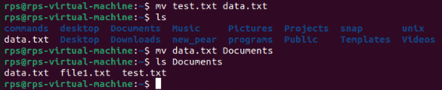

**rm (remove): Deletes files or directories (use with caution!).**

7. Exercise: Important: Only use this after creating a test file (e.g., touch temp.txt). Delete "temp.txt" with rm temp.txt. Never use rm -rf without understanding the risks!

A: **touch temp.txt**

**rm temp.txt -** Deletes files or directories

**ls**

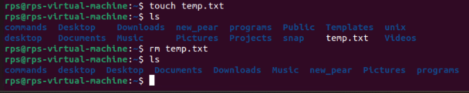

**File Viewing and Permissions:**

**cat (concatenate): Displays the contents of a text file.**

8. Exercise: Create a text file named "message.txt" with some content (e.g., using a text editor). Then, use cat message.txt to view its contents.

A**:** Displays the contents of a text file.

**echo "Hello, World!" > message.txt**

**cat message.txt**

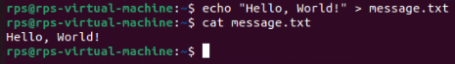

**more (pager): Displays a file's contents one screen at a time (useful for long files).**

9. Exercise: Create a larger text file (e.g., "long_text.txt") and use more long_text.txt to navigate through its content page by page.

A: Displays a file's contents one screen at a time.

# Create a larger text file

**for i in {1..100}; do echo "Line $i"; done > long_text.txt**

**more long_text.txt**

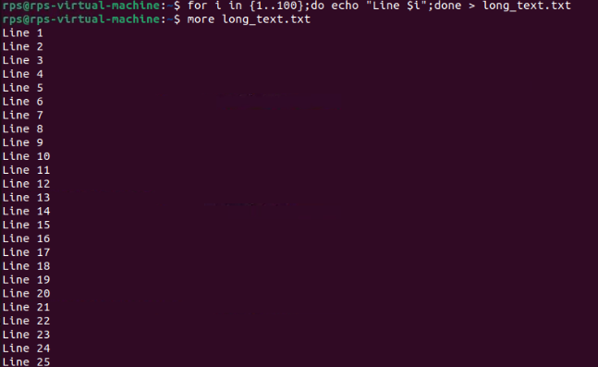

**less (pager): Similar to more, but allows you to move backward in the file.**

10.Exercise: Use less with "long_text.txt" to try moving backward using the Up arrow key.

A: Similar to more, but allows moving backward in the file.

**less long_text.txt**

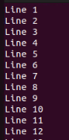

**chmod (change mode): Modifies file permissions (owner, group, others) for read, write, and execute access.**

11. Exercise: This requires understanding permissions. Refer to the man chmod page for details. Proceed with caution when modifying permissions.

A: Modifies file permissions for read, write, and execute access.

# Create a file

**touch file.txt**

# View current permissions

**ls -l file.txt**

# Change permissions to read, write, and execute for the owner

**chmod 700 file.txt**

**ls -l file.txt**

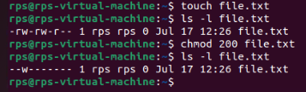

Getting Help and Information:

**man (manual): Provides detailed information about a command.**

12. Exercise: Use man ls or man cd to learn more about these commands.

A: Provides detailed information about a command.

**man ls**

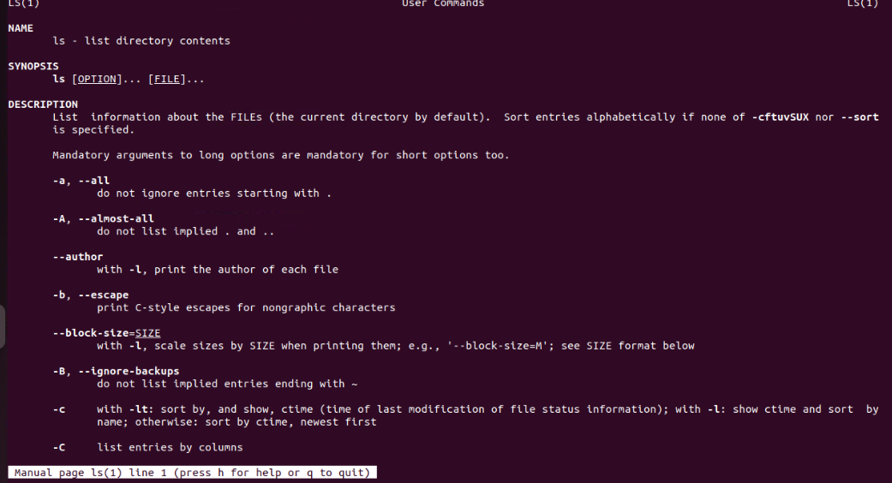

**info (information): Another source of documentation for some commands, often more user-friendly than man**.

13. Exercise: Try info ls or info cd if available on your system.

A: Another source of documentation for some commands.

**info ls**

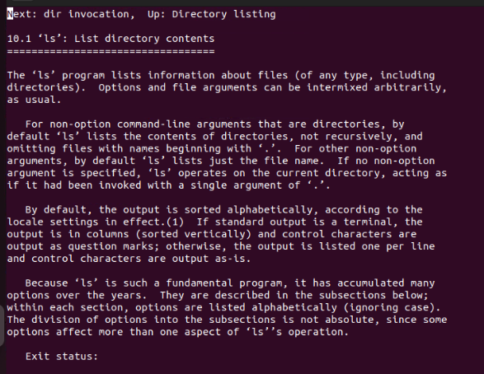

**--help or -h (help flag): Provides a brief overview of a command's usage.**

14. Exercise: Use ls --help or ls -h to see the basic usage options for ls.

A: Provides a brief overview of a command's usage.

**ls –help**

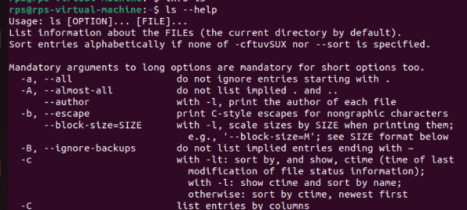

**-------------------------------------------------------------------------------------------------------------------------------**

**Navigation and File Manipulation:**

1.cd ~ && mkdir exercises && cd exercises: Navigate to your home directory, create a new directory named "exercises," and then move into it.

A: **cd ~**

**mkdir exercises**

**cd exercises**

2. cp ../data.txt . (assuming "data.txt" exists in the parent directory): Copy a file named "data.txt" from the parent directory into your current "exercises" directory.

A: **cp ../data.txt .**

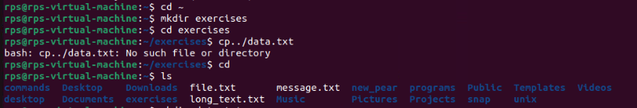

3. mv important_file.txt important_data.txt && touch report.md: Rename a file named "important_file.txt" to "important_data.txt" and create a new Markdown file named "report.md" within the "exercises" directory.

A: **mv important_file.txt important_data.txt**

**touch report.md**

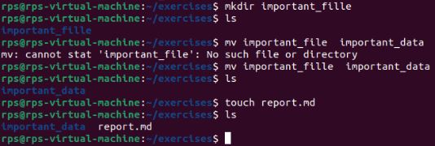

4. cat report.md (assuming the file is empty): View the contents (which should be empty) of the "report.md" file using cat.

A: Displays the contents of the "report.md" file, which should be empty initially.

**cat report.md**

Output: Since the file is empty, no content will be displayed.

5. echo "This is a report" >> report.md: Append a line of text "This is a report" to the "report.md" file using redirection ('>>').

A: Appends the text "This is a report" to the "report.md" file using redirection ('>>').

**echo "This is a report" >> report.md**

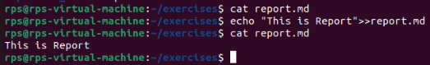

6. less report.md: Use less to view the contents of the "report.md" file, which now contains the appended text.

A: Uses the less command to view the contents of the "report.md" file, which now contains the appended text.

**less report.md**

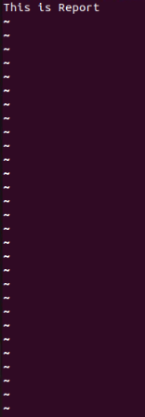

**Finding and Organizing Files:**

7. ls -l | grep 'txt$': List all files in the current directory with the long format (-l) and filter the output using grep to only show files ending with the ".txt" extension.

A: Lists all files in the current directory with the long format (-l) and filters the output using grep to only show files ending with the ".txt" extension.

**ls -l | grep 'txt$'**

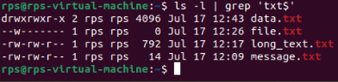

8. find . -name 'data*': Search for all files starting with "data" (including "data.txt", "data_backup.csv", etc.) recursively within the current directory and its subdirectories using find.

A: Searches for all files starting with "data" (including "data.txt", "data_backup.csv", etc.) recursively within the current directory and its subdirectories using find.

**find . -name 'data*'**

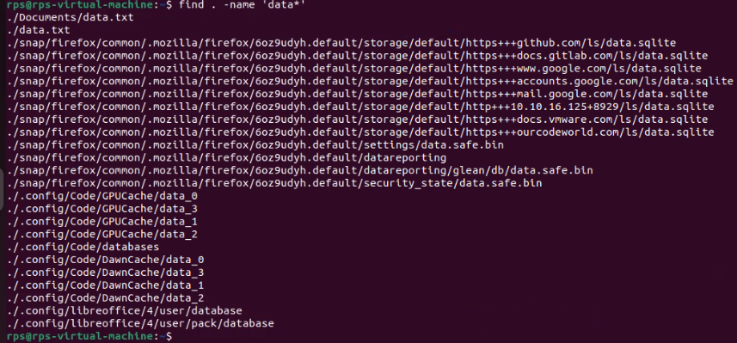

9. mv data* data_archive/: Move all files starting with "data" into a new directory named "data_archive" (create it if it doesn't exist).

A: Moves all files starting with "data" into a new directory named "data_archive". You need to create the "data_archive" directory if it doesn't exist.

**mkdir -p data_archive**

**mv data* data_archive/**

**-------------------------------------------------------------------------------------------------------------------------------**

1. To create a file and write the code in it and execute it.

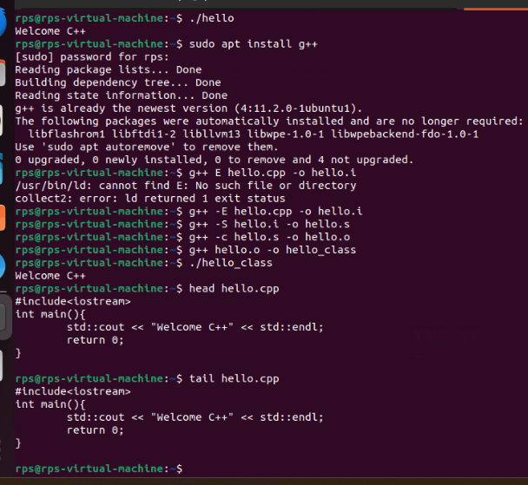

**Commands**

